
- 4 Key Questions

1. How long is my trip?
# of travel days to & from Italy

# of days in Italy

Total days

2. When is my trip?
(month/days/year)

3. Where do I want to go in Italy?

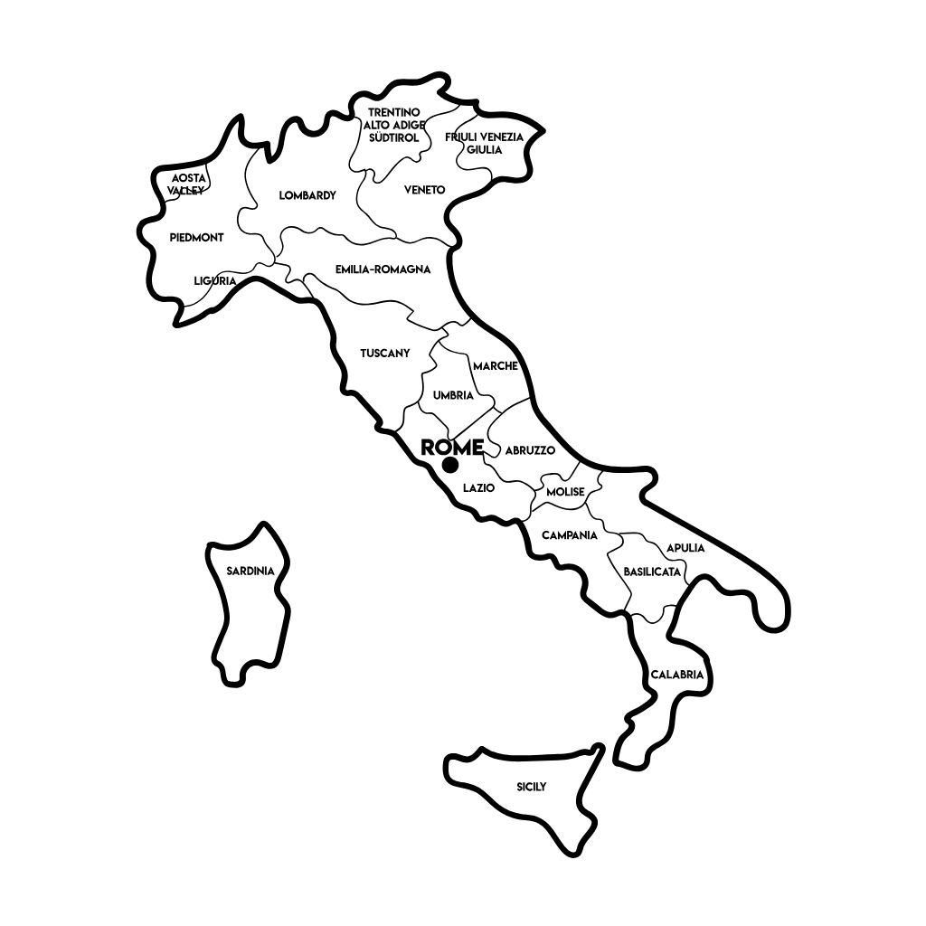
Italy is full of amazing places, offering something for everyone. The country is easiest to think of as having four main areas: the north, the center, the south, and the islands.

Italy is divided into 20 regions, each with its own unique charm. You’ll find majestic mountains in the north, charming towns in the center, sunny beaches in the south, and peaceful islands scattered across its waters. Each region offers something special to discover. And don’t forget about the independent city-states of San Marino and Vatican City, each with its own fascinating history and culture.

Places I want to go in Italy:

Things I want to do in Italy:
(List special things you want to see or do, like tours, historic sites, and museums.)

